Fair trade in Africa
Copy the sentences below and fill in the gaps using one of the connectives in red.

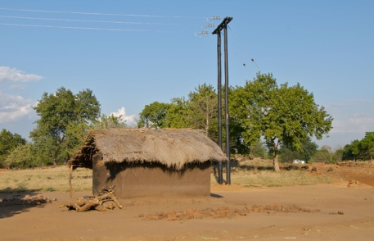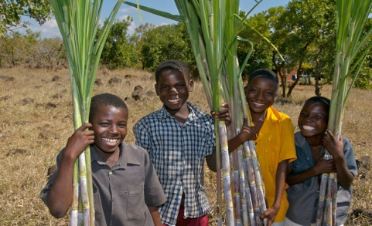

- Chinangwa Village is a small village in Africa a lot of the people who live there are sugar farmers.
And, Because, Or
- The farmers are now growing Fairtrade sugar they have been paid fairly for their sugar.
So, And, Whether
- The extra money from fair trade means they no longer have to walk through the dangerous river drink the dirty water.
Until, Or, So
- Things are better for the villagers now they were able to get a water pump.
If, Because, But
- The villagers are happy about this the crocodile who lives in the river is angry.
If, Whether, But
- The villagers don’t walk through the river any more he can’t snap at their legs!

Because, So, Until

- Colour in the words which have a similar meaning, the first one has been done for you:

Small: Tall Tiny Tight
Dirty: Down Clean Unclean
Happy: Sad Glad Fair
Angry: Drink Now Cross
Dangerous: Safe Dirty Unsafe

